Task # 02: Show the output of examples mention in the lab.

**SOLUTION:**

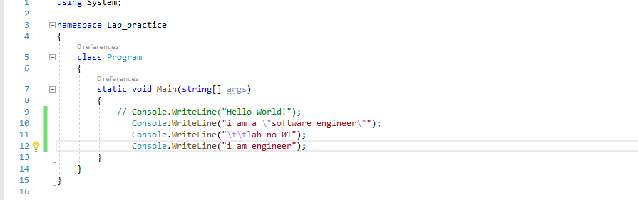

**OUTPUT:**

